Railway Website (Assignment 2)

Balpreet Kaur Dhillon

Continental Institute for International Studies

IMDW -18015

Asst. Prof. Amandeep Singh Sohal

November 12, 2018

***Description of the website-*** The website is about the railway station. In this website people know about the how they can book the online ticket, train between station, running status of train, ticket counter, etc. A railway station is the place where passengers can get on and off trains and also people can get loaded and unloaded things. When people travel by a train it is very a cheap source. It is a comfortable for passengers. It also saves the time because trains cover the long distance in less time as compare to the other vehicles. According to their own choice passenger can select the AC or Non AC seats. Total number of railway station in India is estimated to be between 8,000 and 8,500.

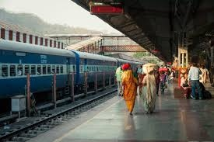

***Features of the railway station-***

* ***Public Utility Service:*** Railways provide an essential service to the passengers. It being a public utility service and it requires protection and investment by government.
* ***Monopoly:*** Railways have monopoly in India. The rail transport is managed by the railways department of the central government. No private operator is allowed to enter this transport sector.
* ***Huge Investment:*** The railway requires huge investment for purchase of land, laying of tracks, constructing railway station and sheds. No single individual can afford to make all these investments.
* ***Privileges:*** The railways require special privileges to provide efficient transport services. Railway require special property rights for purchase of land, construction of bridges and railway lines.
* ***Special Rate Fixation:*** The railways require fix separate rate for passengers and good traffic. The same rates are applicable to all persons and all areas of the country. Rail services are available to all members or the public on equal terms.
* ***Non Transferability:*** Railway lines are laid down then these tracks cannot be used for any purpose. So railway services are non transferable.

***Purpose of the railway station:***

* To entrain or detrain passengers.
* To load or unload goods or parcels.
* To control the movements of train.
* To enable trains to cross each other in the case of a single line section.
* To enable faster trains to overtake slower ones.
* To enable locomotives to refuel, whether it be diesel, water, or coal.
* To attach or detach coaches or wagons to trains.
* To collect food and water for passengers.
* To provide facilities for change of engines and staff.
* To enable sorting out of wagons and bogies to form new trains.
* To provide facilities and give shelter to passengers in the case of emergencies such as floods and accidents, which disrupt traffic.

***Business Model:*** The sliding traffic and income from both freight and passenger. The Indian Railways on Thursday launched Business Plan 2017-18 with mostly on the freight segment which contributes two third of the carrier’s revenue. The plan to increase freight revenue which fell from one crore in 2014-15 to ninety seven crore in 2015-16, a flat growth is estimated from 2016-17 on long term traffic contracts. Introducing double stack dwarf containers and roll on facility for trucks.

***Use Case Diagram:***

Rail infrastructure.

Health and Safety Measures in transportation.

**Administrator**

Railway Framework Legislation.

Check the facilities

Arrive few minutes early at the station

**Users**

Stay Alert

Selling and checking tickets

Making sure that passenger get on and off train safely

**Ticket master role**

Helping to load and unloaded luggage

To conduct supervision over the working of the staff at the station

To maintain Ticket stock books

**Station master**

Responsible for safety

**Description of use case**

Railway framework

Health and safety

Rail Infrastructure

Administrator

**Duties**

Safety

Luggage

Train Safely

Selling and checking ticket

Facilities

Stay alert

Arrive few minutes early

Ticket stock books

Working of the staff

Station Master

Ticket master

User

***Role of administrator-*** The role of the administrator is to understand the characteristics of railway infrastructure: rail technology, rail junction. The manager are in charge of organising tasks linked to the operation of train stations. They care comfort, services, safety and security of passengers and the commercial use of buildings.

***Role of users-*** Responsibilities of the users is arrive few minutes early in railway station. Users check all the facilities in railway station like reserved seat, luggage. Users check the working style of railway station. Users stay alert and they check the luggage after few time.

***Role of ticket master-*** In ticket counter they sale the ticket. They make sure that passengers get on and off train safely. The responsibilities of the ticket master are collect the fines when passengers do wrong things.

***Role of station master-*** To attend duty in time in neat and clean uniform and to see that all staff reports for duty in time and in uniform. To conduct over the working of the staff at the station. To hold safety meeting and discuss safety rules circulated by divisional office for the monthly meeting to be held on day.

***Content plans:-***

In this website firstly I make prototypes of railway station. In first prototype the welcome page is here. In second page the train is here. In third prototype I discuss about the trains between the stations where people check the arrival and departure time of the train. In fourth prototype is about the running status of the train. Moreover, in fifth prototype is about the online ticket where people book a ticket from the home. Furthermore, in sixth prototype is fare description. In fare description passenger check the price of ticket. In seventh prototype, it is a seat prototype. In this prototype the seats are upper berth, lower berth, lower berth, side upper, side middle, side lower, etc. Moving ahead, in eight prototype is about the login form of administrator. In ninth prototype is about the station master. In last prototype, is about the ticket counter and users where passenger book a ticket.



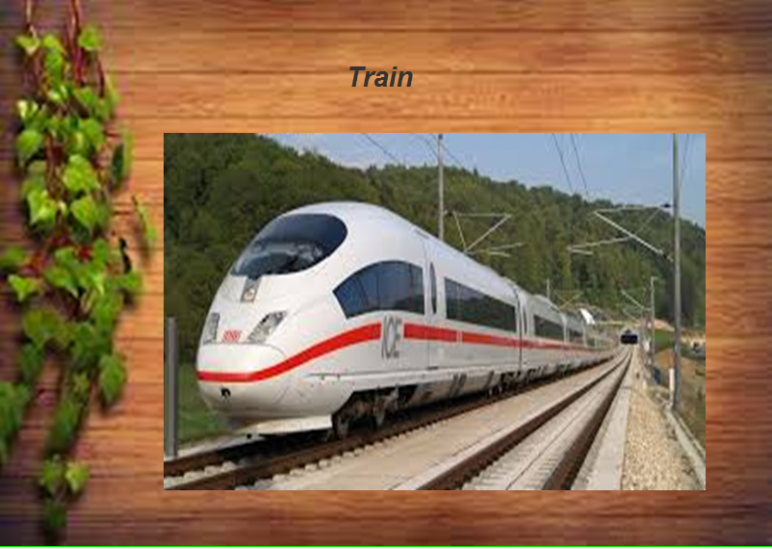

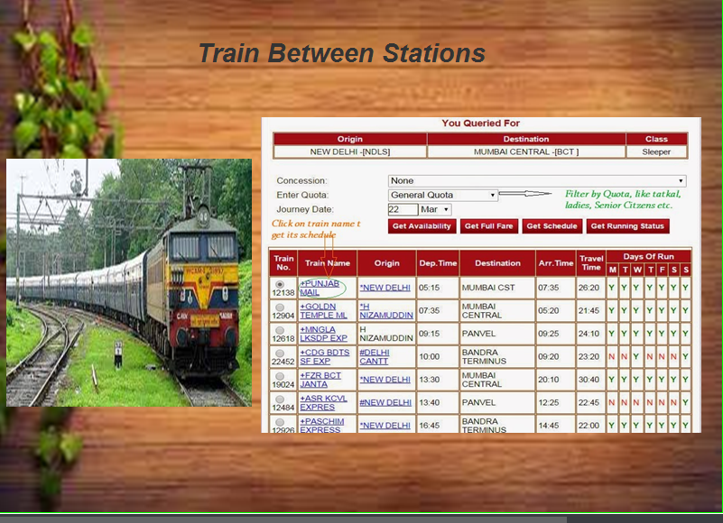

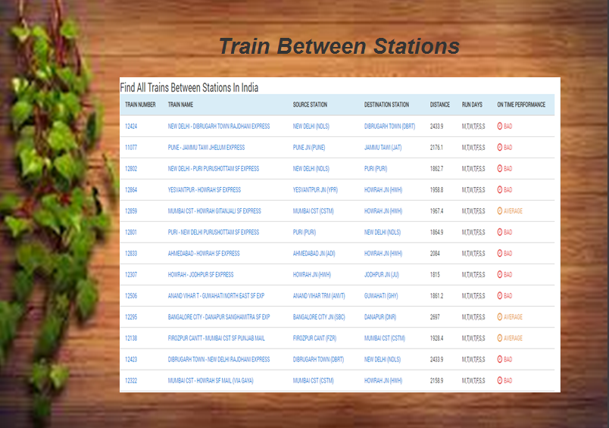

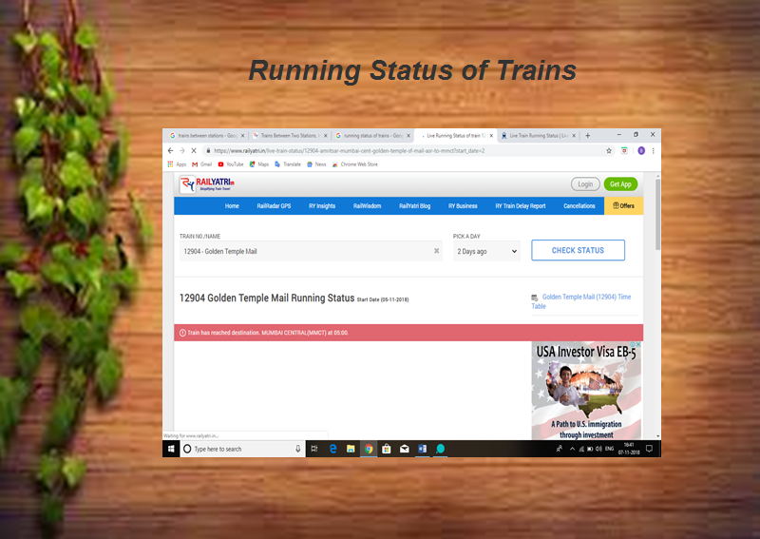

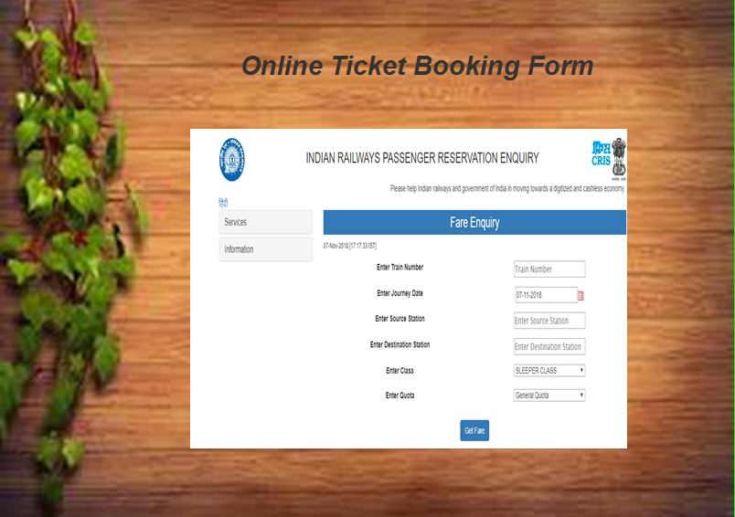

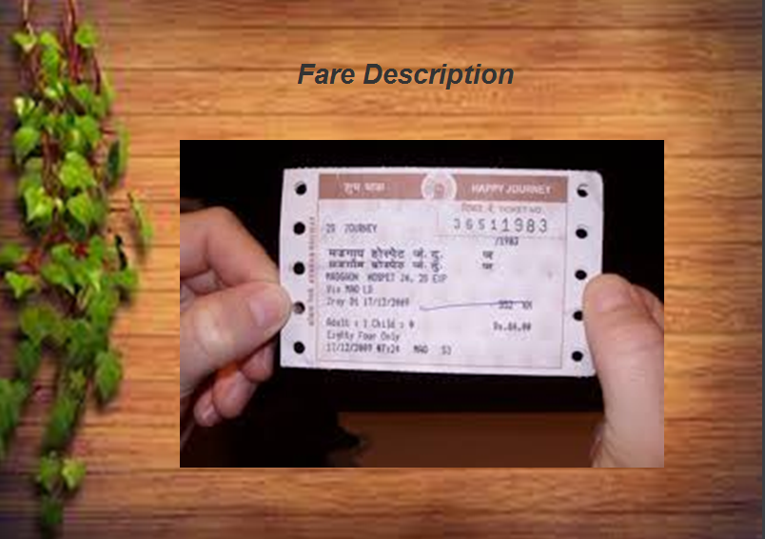

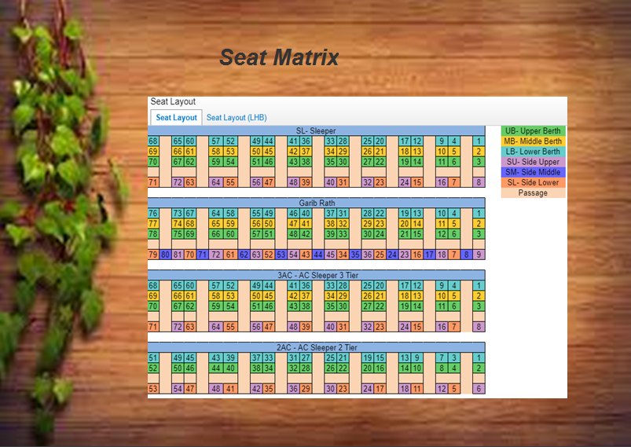

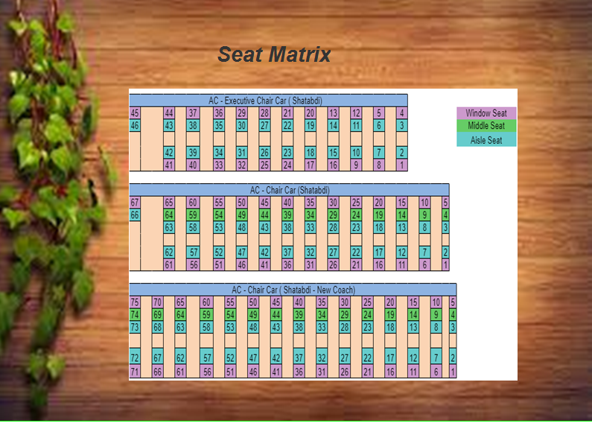

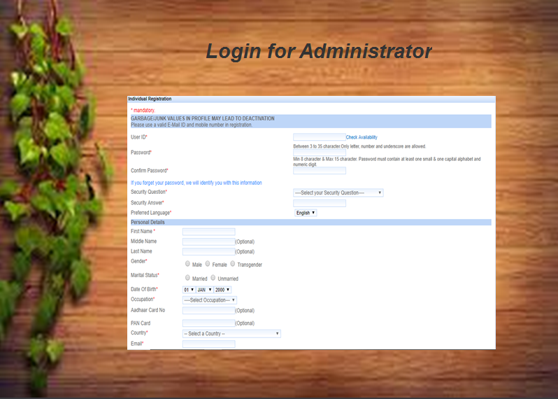

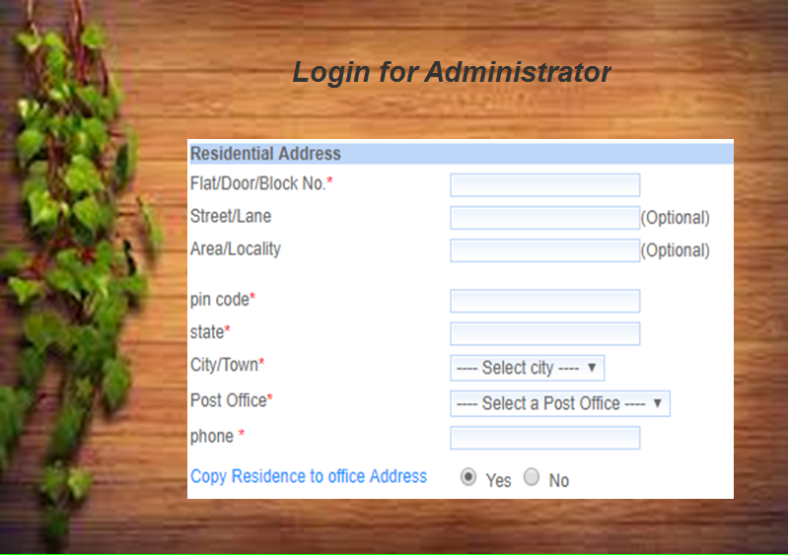



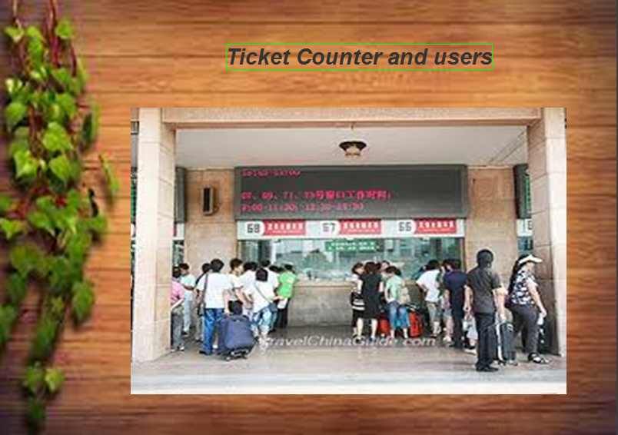

**References**

Retrieved from:

<https://www.irctc.co.in/>

|  |
| --- |
|  |